**Design and Development of Befit website**

**A**

**PROJECT REPORT**

Submitted in partial fulfillment of the requirements for the degree of

##### BACHELOR OF TECHNOLOGY

in

##### COMPUTER SCIENCE & ENGINEERING

##### By

**0187CS221219 Yadav Aman Prabhat**

##### 0187CS221187 Shivanshu Kumar

##### Under the guidance of

##### Prof. Amit Kumar Rathore

##### Assistant



##### December-2023

##### Department of Computer Science & Engineering Sagar Institute of Science & Technology (SISTec) Bhopal (M.P.)

**Approved by AICTE, New Delhi & Govt. of M.P.**

**Affiliated to Rajiv Gandhi Proudyogiki Vishwavidyalaya, Bhopal (M.P.)**

**INDEX**

|  |  |  |
| --- | --- | --- |
| **TITLE** | | **PAGE NO.** |
| Chapter 1 | Introduction | 1 |
| Chapter 2 | Hardware and Software Requirement | 2 |
|  | Introduction | 2 |
|  | Software Requirement | 2 |
|  | Hardware Requirement | 2 |
| Chapter 3 | Coding | 3-20 |
| Chapter 4 | Output Screens | 21-23 |
| Chapter 5 | Conclusion & | 24 |
|  | Future Work | 24 |
| References |  | 25 |

Project Summary 26

Project Narrative 27

# CHAPTER – 1 INTRODUCTION

**Welcome to [Your Website Name] - Your Ultimate COVID Awareness Hub!**

In these challenging times, staying informed about COVID-19 is crucial for our well-being and the well-being of our communities. Our website is dedicated to providing you with comprehensive and accurate information to raise awareness about COVID-19, guide you on precautionary measures, share vital information, and debunk myths surrounding the virus.

**What You'll Find Here:**

**Precautionary Measures**

Discover effective and practical ways to protect yourself and others from the spread of COVID-19. We offer simple guidelines on hygiene practices, mask-wearing, and social distancing to help you navigate through these uncertain times.

S**ymptoms and Testing**:

Familiarize yourself with the common symptoms of COVID-19 and learn about the importance of testing. Early detection plays a crucial role in preventing the spread of the virus, and we're here to guide you on the steps to take if you or someone you know experiences symptoms.

**Important Information:** Stay updated with the latest information and guidelines from reputable health organizations. From vaccination updates to travel advisories, we've got you covered with the most relevant and reliable information. **Quick Links:**

Access important resources at your fingertips. Our quick links section provides easy navigation to official health websites, emergency contacts, and other valuable sources to keep you well-informed.

**Myth vs. Facts:**

Addressing misconceptions is crucial in the fight against COVID-19. Explore our myth-busting section to separate fact from fiction and make informed decisions about your health. At [Your Website Name], we believe that knowledge is a powerful tool in combating the pandemic. Our mission is to empower you with accurate information, promote awareness, and foster a sense of community resilience. Remember, together we can overcome this challenge. Stay informed, stay safe!

**CHAPTER-2**

**Software & Hardware Requirements**

##### INTRODUCTION

At FitGear Hub, we believe that a healthy lifestyle begins with the right fitness equipment. Our online platform is meticulously designed to be your go-to destination for a wide range of top-notch fitness gear, catering to enthusiasts of all levels. Whether you're a cardio enthusiast, a yoga devotee, or a strength training pro, FitGear Hub is here to elevate your fitness journey.

##### SOFTWARE REQUIREMENTS

* + - Operating System : Windows, Linux, etc
    - Front-End : HTML, CSS, JAVASCRIPT

**2.3. HARDWARE REQUIREMENTS**

* + Processor: Dual-core 64-bit processor.
  + RAM: 2 GB(MIN.).
  + Hard Disk: 256GB (MIN.).
  + Proper Internet connection.

# CHAPTER:- 3

# CODING

**3.1 Coding**

**Login.html**

<!DOCTYPE html>

<html lang="en">

<head>

<style>

*

{

margin: 0;

padding:0 ;

box-sizing: border-box;

}

html

{

font-family: 'Roboto', sans-serif;

}

::-webkit-scrollbar

{

width: 15px;

}

::-webkit-scrollbar-track

{

background-color: #0056C6;

height: 40px;

}

::-webkit-scrollbar-thumb

{

background-color: #3d67c3;

border-radius: 20px;

}

.login

{ height: 100vh;

width: 100%;

display: flex;

justify-content: space-around;

position: relative;

& h4

{

margin-top: 600px;

}

& .image

{

width: 100%;

height: 100vh;

&::after

{

content: "BeFit.";

position: absolute;

top: 25px;

left: 40px;

font-size: 50px;

color: white;

font-weight: 500;

}

}

& img

{

width:100%;

height: 100vh;

object-fit: cover;

}

& .form

{

height: auto;

width: 50%;

background-color: whitesmoke;

display: flex;

flex-direction: column;

justify-content: center;

align-items: center;

& form

{

& h1

{

color: #508EAF;

}

height: 90vh;

width: 515px;

/* background-color: rgb(142, 142, 142) ; */

display: flex;

flex-direction: column;

justify-content: center;

align-items: center;

gap: 70px;

& input

{

height: 50px;

width: 424px;

font-size: 20px;

border: 4px solid #508EAF;

color: #0056C6;

/* border: 2px solid rgb(202, 8, 8); */

background-color: rgb(255, 255, 255);

text-align: center;

}

& button {

display: flex;

justify-content: center;

align-items: center;

width: 221px;

height: 100px;

border: none;

font-size: 30px;

font-weight: 400px;

border-radius: 8px;

background-color: #9c4e75;

font-weight: 500;

color: white;

a

{

text-decoration: none;

color: white;

}

}

& button:hover

{

background-color: black;

}

}

}

}

.down

{

color: rgb(0, 0, 0);

font-size: 30px;

font-weight: 400;

}

</style>

<meta charset="UTF-8">

<meta name="viewport" content="width=device-width, initial-scale=1.0">

<title>Document</title>

</head>

<body>

<!-- <a href="../../../befit.html"> <h4>BeFit<font style="color: red;font-size: 60px;">.</font></h4></a> -->

<div class="login">

<div class="image">

<img src="img/stepping-beautiful-young-female-athlete-practicing-monochrome-blue-portrait-sportive-fit-brunette-model-with-jump-box-weights-wellness-healthy-lifestyle-beauty-action-concept.jpg" alt="">

</div>

<div class="form">

<form action="">

<h1>LOGIN</h1>

<input type="text" placeholder="username@gmail.com">

<input type="password" placeholder="password">

<button class="login" onclick="befit.html" ><a href="../befit.html">LOGIN</a></button>

<a href="signup/signup.html" class="down">Sign up</a>

</form>

</div>

</div>

</body>

</html>

**Befit.html**

<!DOCTYPE html>

<html lang="en">

<head>

<link rel="stylesheet" href="https://cdnjs.cloudflare.com/ajax/libs/font-awesome/6.5.1/css/all.min.css" integrity="sha512-DTOQO9RWCH3ppGqcWaEA1BIZOC6xxalwEsw9c2QQeAIftl+Vegovlnee1c9QX4TctnWMn13TZye+giMm8e2LwA==" crossorigin="anonymous" referrerpolicy="no-referrer" />

<link rel="stylesheet" href="befit.css">

<meta charset="UTF-8">

<meta name="viewport" content="width=device-width, initial-scale=1.0">

<title>Document</title>

<link rel="stylesheet" href="https://cdnjs.cloudflare.com/ajax/libs/materialize/1.0.0/css/materialize.min.css" integrity="sha512-UJfAaOlIRtdR+0P6C3KUoTDAxVTuy3lnSXLyLKlHYJlcSU8Juge/mjeaxDNMlw9LgeIotgz5FP8eUQPhX1q10A==" crossorigin="anonymous" referrerpolicy="no-referrer" />

</head>

<body>

<div class="navbar">

<a href="../../../befit.html"> <h4>BeFit<font style="color: red;font-size: 60px;">.</font></h4></a>

<div class="nav-end">

<a href="/products/main.html" class="products line">PRODUCTS</a>

<a href="../../../about-us/about_us.html" class="about-us line">ABOUT</a>

<a href="../../../favourite/fav.html" class="blog line"><i class="fa-solid fa-heart"></i></a>

<a href="../../../cart/cart.html" class="cart line"><i class="fa-solid fa-cart-shopping"></i></a>

<div class="login line"><a href="/login/login.html">LOGIN</a></div>

</div>

</div>

</div>

<div class="img-scroll">

<div class="main">BeFit.</div>

</div>

<!-- SECTION-2 -->

<section class="section-2">

<div class="main-2">

<img src="images/s2/01.jpg" class="img-3" alt="">

<img src="images/s2/02.jpg" class="img-3 img-02" alt="">

<img src="images/s2/03.jpg" class="img-3" alt="">

<img src="images/s2/05.jpg" class="img-3 img-02" alt="">

</div>

<div class="para">

<h2>Transform Your Space</h2>

<p>

Discover fitness gear that not only enhances your workout but transforms your home. Stylish and space-efficient, our equipment is designed to complement your living environment. </p>

</div>

</section>

<!-- SECTION-3 -->

<section class="section-3">

<div class="main-2">

<div class="img-section">

<img src="images/s3/1.jpg" alt="">

</div>

<div class="content">

<h3>EXPERTLY CURATED COLLECTIONS</h3>

<p>Explore our expertly curated collections, handpicked to meet diverse fitness needs. Whether you're a beginner or a fitness enthusiast, we have the perfect equipment for you.</p>

</div>

</div>

</section>

<!-- HERE IS THE SECTION 04 -->

<section class="section-4">

<div class="main-4">

<div class="content-1 cot">

<img src="images/s4/weights-exercise-weightlifter-strong-athletic.jpg" class="img1">

<div class="text1">

<h1 id="h1-col">Personalized Home Gym Solutions</h1>

<p class="para">Create your ideal home gym with our personalized solutions. We offer a range of equipment to fit your space, budget, and fitness goals, ensuring a tailored workout experience.Create your ideal home gym with our personalized solutions. We offer a range of equipment to fit your space, budget, and fitness goals, ensuring a tailored workout experience.

</p>

</div>

</div>

<div class="content-1">

<div class="text1">

<h1>Convenient Shopping Experience.</h1>

<p class="para para1">A convenient shopping experience seamlessly integrates user-friendly interfaces, swift navigation, and efficient transaction processes. It prioritizes customer satisfaction by offering intuitive search options, clear product information, and hassle-free checkout, ensuring a streamlined journey from selection to purchase.</p>

</div>

<img src="images/s4/2.jpg" alt="" class="img2">

</div>

</div>

</section>

<!-- SECTION-05 -->

<div class="white-strip"></div>

<section class="section-5">

<div class="main-5">

<div class="contain">

<div class="img-section">

<img src="images/s5/2.jpg" alt="">

</div>

</div>

<div class="content">

<h1>Premium Gym Equipment</h1>

<p>Elevate your home workouts with our premium gym equipment. From durable dumbbells to state-of-the-art cardio machines, we bring the gym experience to you.

</p>

</div>

</div>

</section>

<!-- SECTION_06 -->

<div class="section-6">

<h1>Feedback Zone

</h1>

<div class="carousel">

<a href="#" class="carousel-item">

<div class="card">

<div class="peopele-img">

<img src="images/s6/1.png" alt="">

</div>

<div class="comment">

<h4>virat kholi</h4>

<p>"Just got my hands on the new dumbbell set from this site, and I'm loving it! The quality is top-notch, and the grip feels solid. Perfect addition to my home gym. Thanks for the recommendation"</p>

</div>

</div>

</a>

<a href="#" class="carousel-item">

<div class="card">

<div class="peopele-img">

<img src="images/s6/2.png" alt="">

</div>

<div class="comment">

<h4>sophia</h4>

<p>"Absolutely in love with the yoga mat I purchased here. It's thick, non-slip, and the color options are great. The quality is fantastic, and it adds a touch of style to my daily workouts. Highly recommended!"</p>

</div>

</div>

</a>

<a href="#" class="carousel-item">

<div class="card">

<div class="peopele-img">

<img src="images/s6/3.png" alt="">

</div>

<div class="comment">

<h4>Aman yadav</h4>

<p>"The rowing machine I ordered exceeded my expectations. It's sturdy, smooth, and provides an excellent full-body workout. The customer service was also fantastic. Highly recommend!"</p>

</div>

</div>

</a>

<a href="#" class="carousel-item">

<div class="card">

<div class="peopele-img">

<img src="images/s6/4.png" alt="">

</div>

<div class="comment">

<h4>Shivanshu kumar</h4>

<p>"Recently started my fitness journey, and this site has been a game-changer. The curated collections made it easy for me to pick the right gear for my home gym. Can't wait to see the results!"</p>

</div>

</div>

</a>

<a href="#" class="carousel-item">

<div class="card">

<div class="peopele-img">

<img src="images/s6/05.png" alt="">

</div>

<div class="comment">

<h4>Emma</h4>

<p>"The resistance bands are a must-have! They're versatile, durable, and perfect for toning exercises. The variety in resistance levels allows me to customize my workout. A fantastic addition to my fitness routine."</p>

</div>

</div>

</a>

<a href="#" class="carousel-item">

<div class="card">

<div class="peopele-img">

<img src="images/s6/6.png" alt="">

</div>

<div class="comment">

<h4>Olivia</h4>

<p>"Bought the stylish gym bag from this website, and I'm impressed! It's spacious, has separate compartments, and the design is on point. It's become my go-to bag for both the gym and weekend getaways."</p>

</div>

</div>

</a>

</div>

</div>

<!-- footer-section -->

<div class="footerl">

<div class="social-logo">

<a href="https://www.youtube.com/"><img src="images/logos/1.png" class="logo-img" alt=""></a>

<a href="https://www.linkedin.com/feed/?trk=guest_homepage-basic_google-one-tap-submit"><img src="images/logos/2.jpg" class="logo-img" alt=""></a>

<a href="https://www.instagram.com/"><img src="images/logos/3.png" class="logo-img" alt=""></a>

<a href="https://in.pinterest.com"><img src="images/logos/4.jpg" class="logo-img" alt=""></a>

<a href="https://web.whatsapp.com/"><img src="images/logos/5.png" class="logo-img" alt=""></a>

</div>

<div class="content">

<a href="/befit.html"><h5>home</h5></a>

<a href="/about-us/about_us.html"><h5>about</h5></a>

<a href="/products/main.html"><h5>services</h5></a>

<a href=""><h5>login</h5></a>

</div>

</div>

<div class="copyright">&copy; 2023 BeFit. All Rights Reserved.</div>

<script src="https://cdnjs.cloudflare.com/ajax/libs/jquery/3.7.1/jquery.min.js"

integrity="sha512-v2CJ7UaYy4JwqLDIrZUI/4hqeoQieOmAZNXBeQyjo21dadnwR+8ZaIJVT8EE2iyI61OV8e6M8PP2/4hpQINQ/g=="

crossorigin="anonymous" referrerpolicy="no-referrer"></script>

<script src="https://cdnjs.cloudflare.com/ajax/libs/materialize/1.0.0/js/materialize.min.js"

integrity="sha512-NiWqa2rceHnN3Z5j6mSAvbwwg3tiwVNxiAQaaSMSXnRRDh5C2mk/+sKQRw8qjV1vN4nf8iK2a0b048PnHbyx+Q=="

crossorigin="anonymous" referrerpolicy="no-referrer"></script>

<script type="text/javascript">

$(document).ready(function () {

$('.carousel').carousel({

indicators: true

});

})

</script>

</body>

</html>

**Befit.css**

*

{

margin: 0;

padding: 0;

box-sizing: border-box;;

}

html

{

font-family: 'Roboto', sans-serif;

scroll-behavior: smooth;

}

::-webkit-scrollbar

{

width: 10px;

height: 2px;

}

::-webkit-scrollbar-track

{

background-color: #ffffff;

height: 40px;

}

::-webkit-scrollbar-thumb

{

background-color: #000000;

/* border-radius: 20px; */

/* height: 2px; */

}

.navbar

{

width: 100%;

height: 100px;

/* background-color: black; */

color: black;

display: flex;

justify-content: space-between;

align-items: center;

padding: 0px 110px;

margin-top: 40px;

& h4

{

font-size: 30px;

font-weight: 700;

}

& .login

{

padding: 20px 40px;

background-color: black;

border-radius: 10px;

display: flex;

justify-content: center;

align-items: center;

& a

{

color: white;

font-size:25px ;

display: flex;

justify-content: center;

align-items: center;

text-decoration: none;

}

}

& a

{

text-decoration: none;

color: black;

}

& .nav-end

{

/* width: 500px; */

display: flex;

justify-content: space-around;

align-items: center;

font-size: 30px;

gap: 50px;

position: relative;

& .products

{

font-weight: 500;

font-size: 25px;

}

& .about-us

{

font-weight: 500;

font-size: 25px;

}

}

& .line

{

display: inline;

&::after{

content: "";

position: absolute;

transition: all 1s linear;

}

& .fa-heart:hover

{

transform: all 2s linear;

color: red;

}

& .fa-cart-shopping:hover

{

color: rgb(150, 0, 210);

}

}

& .line:hover

{

transition: all 0.2s linear;

border-bottom: 0.2rem solid red;

width: 100%;

}

& .login{

transition: all 0.5s linear;

font-weight: 500;

}

& .login:hover

{

background-color: #F44646;

border-bottom: none;

/* border: 2px solid black; */

box-shadow: rgba(0, 0, 0, 0.19) 0px 10px 20px, rgba(0, 0, 0, 0.23) 0px 6px 6px;

& a {

color: black;

};

}

}

.img-scroll

{

height: 1200px;

width: 100%;

display: flex;

justify-content: center;

align-items: center;

& .main

{

font-size: 100px;

height: 80%;

width: 90%;

color: rgb(221, 32, 32);

display: flex;

justify-content: center;

align-items: center;

font-weight: 900;

border-radius: 10px;

background-image: url("https://wallpaperaccess.com/full/53182.png");

background-size: cover;

animation: gallery 15s linear infinite;

box-shadow: rgba(0, 0, 0, 0.3) 0px 19px 38px, rgba(0, 0, 0, 0.22) 0px 15px 12px;

}

}

@keyframes gallery

{

0%{

background-image: url("images/scroll/1.jpg");

}

20%

{

background-image: url("images/scroll/2.jpg");

}

40%

{

background-image: url("images/scroll/3.jpg");

}

60%

{

background-image: url("images/scroll/4.jpg");

}

80%

{

background-image: url("images/scroll/5.jpg");

}

100%

{

background-image: url("images/scroll/1.jpg");

}

}

/* SECTION */

.section-2

{

height: 1200px;

width: 100%;

background-color: black;

& .main-2

{ margin-top:30px;

width: 100%;

display: flex;

justify-content:center;

align-items: center;

gap: 60px;

& .img-3

{

height: 500px;

width: 300px;

object-fit: cover;

margin-top: 200px;

}

& .img-02

{

margin-top: -15px;

}

}

& .para{

height: 200px;

width: 100%;

color: white;

display: flex;

flex-direction: column;

justify-content: center;

align-items: center;

margin-top: 200px;

& h2{

color: #FFA02D;

font-weight: 600;

text-transform: uppercase;

}

& p

{

width: 1000px;

font-size: 25px ;

text-align: center;

line-height: 32px;

}

}

}

/* SECTION 03 */

.section-3

{

width: 100%;

height: auto;

& .main-2

{ width: 100%;

display: flex;

height: 100%;

position: relative;

& img

{

height: 1200px;

width:100% ;

}

& .content

{

width: 70vh;

height: 50%;

position: relative;

left:-110px;

background-color: rgb(255, 198, 113);

/* margin-left: -240px; */

margin-top: 325px;

margin-right: 200px;

padding: 50px;

display: flex;

flex-direction: column;

justify-content: center;

border: 20px solid white;

& h3

{

font-size: 55px;

font-weight: 600;

}

& p {

font-size: 30px;

font-weight: 400;

}

}

}

}

/* HERE IS THE SECTION 04 */

.section-4

{

width: 100%;

height: auto;

background-color: black;

& .main-4

{

border-radius: 20px;

display: grid;

grid-template-columns: repeat(2,1fr);

}

& .content-1

{

display: grid;

grid-template-rows: repeat(2,1fr);

& h1

{

color:#ffffff;

font-size: 50px;

font-weight: 500;

line-height: 107px;

}

& .para

{

color: black;

font-size: 31px;

font-weight: 400;

}

& .para1

{

color: rgb(0, 0, 0);

font-weight: 400;

}

}

& .img1

{

height: 100%;

width: 100%;

object-fit: cover;

}

& .img2

{

height: 100%;

width: 100% ;

object-fit: cover;

border-radius: 10px;

}

.text1

{

height: 100%;

width: 100%;

padding: 170px;

background-color: #FC4A39;

}

& .cot

{

background-color: white;

}

}

/* .white-strip

{

background-color:white;

height: 50px;

width: 100%;

} */

/* section 5 is here */

.section-5

{

width: 100%;

height: 100%;

background-color: antiquewhite;

& .main-5

{ width: 100%;

height: 1200px;

display: flex;

justify-content: center;

align-items: center;

& .contain

{

height: 1200px;

width:100% ;

background-color:#713E5A;

display: flex;

justify-content: center;

align-items: center;

}

& .img-section

{ display: flex;

justify-content: center;

align-items: center;

height: 1200;

width: 1300px;

& img

{

width: 80%;

height: 80%;

border-radius: 20px;

object-fit: cover;

display: flex;

justify-content: center;

align-items: center;

box-shadow: rgba(0, 0, 0, 0.2) 0px 60px 40px -7px;

/* box-shadow: rgba(0, 0, 0, 0.3) 0px 19px 38px, rgba(0, 0, 0, 0.22) 0px 15px 12px; */

/* margin-left: 40px; */

}

}

& .content

{

height: 50vh;

width:auto;

/* background-color: aquamarine; */

font-size: 22px;

padding: 100px;

& h1

{ display: inline;

/* text-transform: uppercase; */

font-weight: 500;

line-height: 100px;

}

& p

{

font-weight:400;

font-size: 27px;

}

}

}

}

/* section 6 */

.section-6

{

width: 100%;

height: auto;

background-color: black;

position: relative;

& h1

{

color: white;

text-align: center;

font-weight: 800;

padding: 100px;

/* background-color: #713E5A; */

}

& .carousel

{

width: 100%;

height: 1200px;

& .carousel-item

{

border-radius: 100

px;

width: 500px;

height: 700px;

display: flex;

justify-content: center;

align-items: center;

& .card

{

height: 100%;

width:100%;

align-items: center;

display: flex;

flex-direction: column;

justify-content: center;

align-items: center;

& img

{

height: 200px;

width: 200px;

border-radius: 50%;

background-color: rgb(0, 0, 0);

object-fit: cover;

transform: translateY(-100px);

}

& .comment

{

padding: 80px;

height: 60%;

width:90%;

background-color: black;

border-radius: 20px;

& h4

{

text-align: center;

color: black;

line-height:30px ;

padding: 20px;

background-color: white;

border-radius: 10px;

text-transform: uppercase;

font-size: 20px;

font-weight: 600;

}

& p {

color: rgb(141, 141, 141);

font-size: 20px;

text-align: center

};

}

}

}

}

}

/* footer */

.footerl

{

width: 100%;

height: 700px;

display: flex;

flex-direction: column;

justify-content: center;

align-items: center;

/* display: grid;

grid-template-rows: repeat(3,1fr); */

& .social-logo

{ width: 100%;

height: auto;

display: flex;

flex-direction: row;

justify-content: center;

align-items: center;

/* display: grid;

grid-template-columns: repeat(3,1fr); */

& img

{

height: 90px;

width: 90px;

filter: grayscale(0%);

object-fit: cover;

}

& .logo-img:hover

{

filter: grayscale(100%);

transform: rotate(360);

}

}

& .content

{

display: flex;

justify-content: center;

align-items: center;

gap: 80px;

text-transform: uppercase;

& h5

{

font-weight: 500;

}

}

}

.copyright

{

display: flex;

justify-content: center;

align-items: center;

background-color: black;

color: white;

height: 100px;

font-size: 23px;

}

**Chapter – 4**

**Output**

**Signup Screen:**

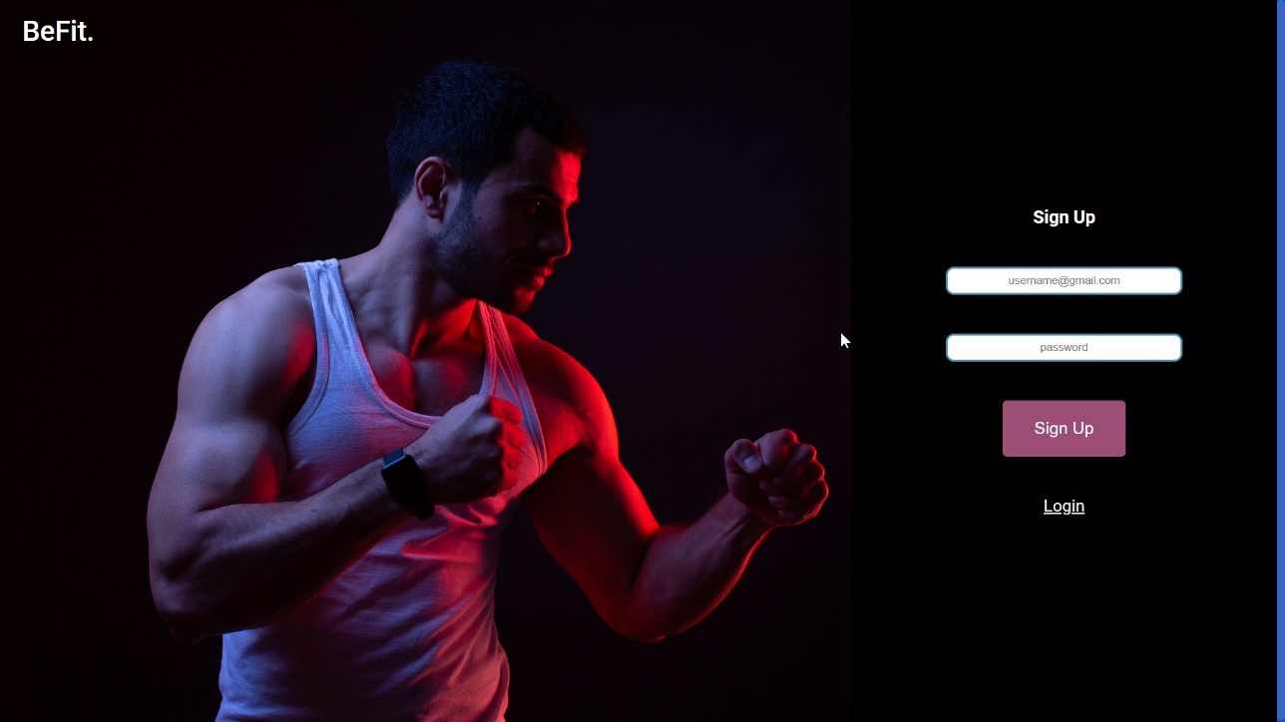

**Figure 4.1** Signup Screen

**Home Screen:**

**Figure 4.2** Home Screen

**Figure: -4.3** Premium Gym Equipment

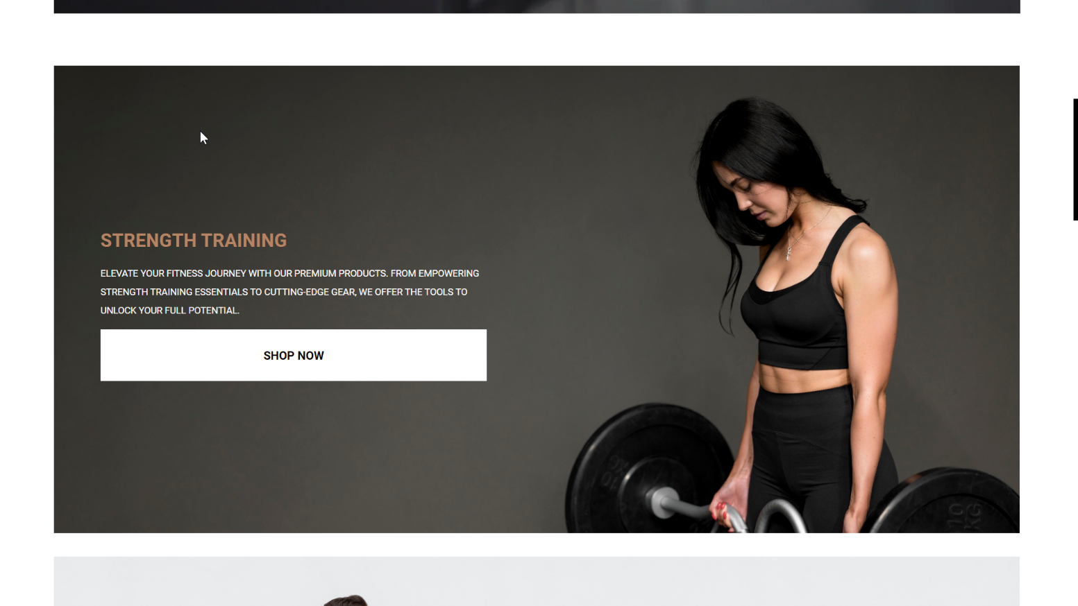

**Figure:** Product for shopping

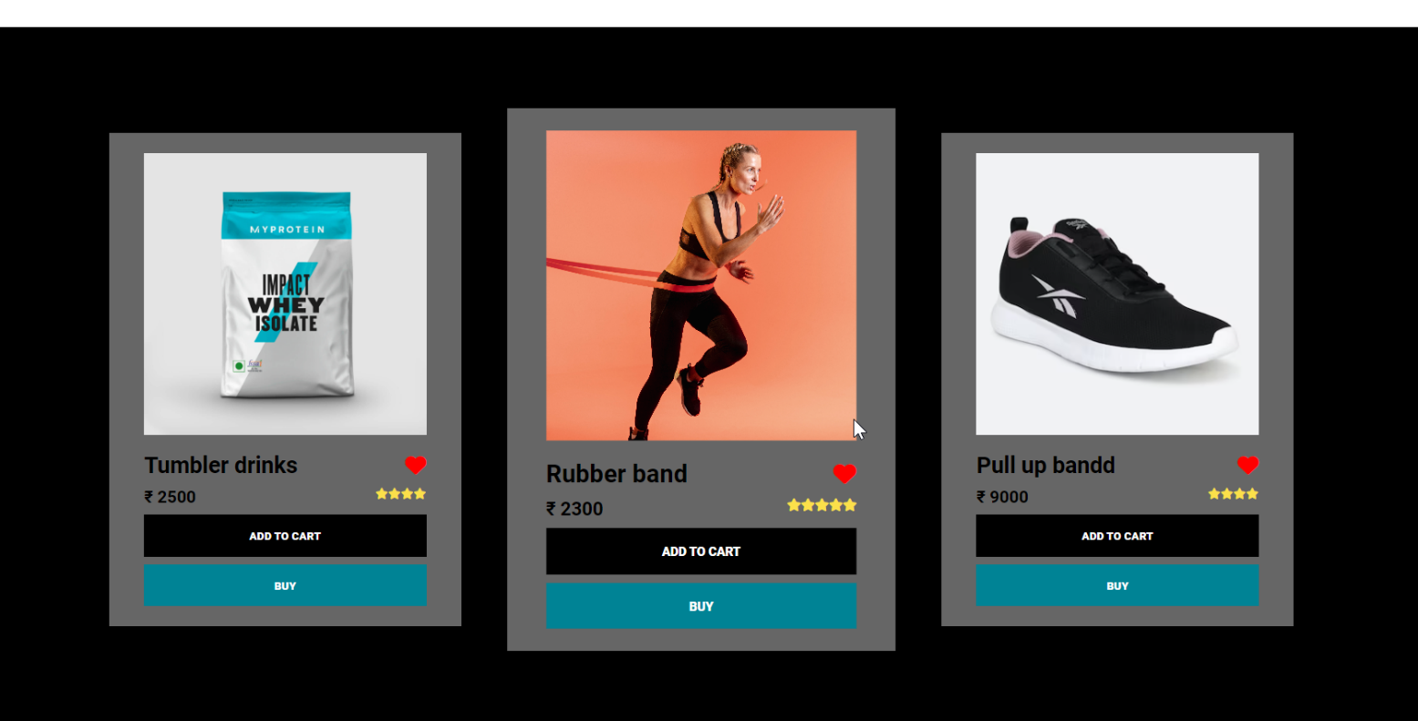

**Figure:-4.5** Cart Item

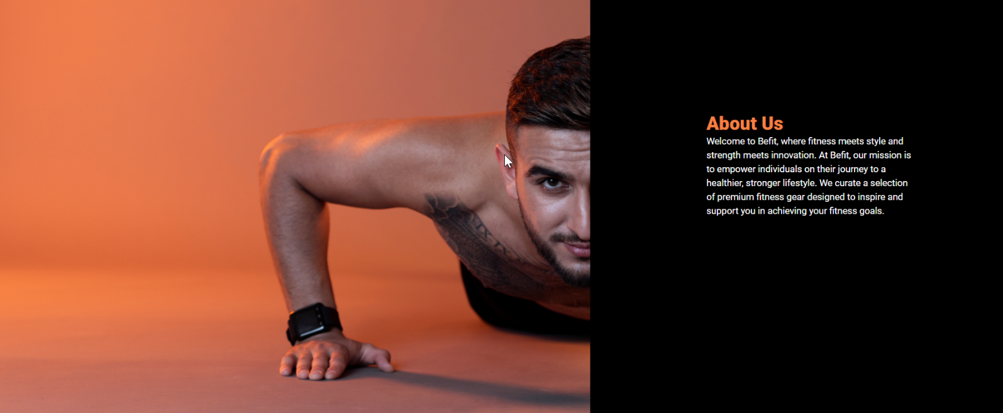

**Figure:-4.6** About us

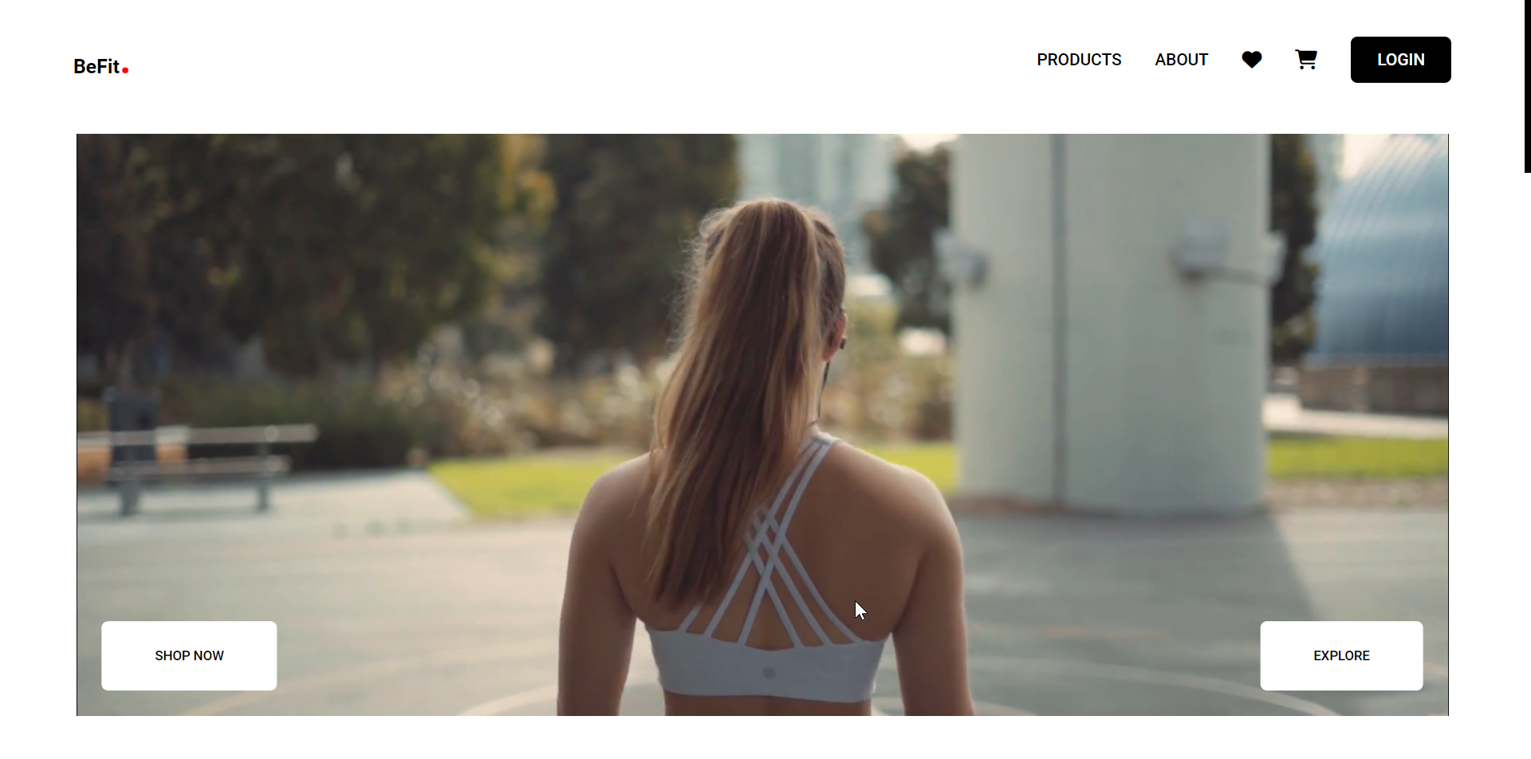

**Figure:-4.8 :** products

**Figure:-4.8 :** Community

**Figure:-4.8 :** Our mission

**CHAPTER-5**

**CONCLUSION & FUTURE WORK**

* 1. **CONCLUSION**

In conclusion, BeFit is not just a website; it's your personalized gateway to a healthier and more empowered lifestyle. Our commitment to user-friendly design, diverse product offerings, and a secure shopping experience reflects our dedication to your well-being. As you navigate through our platform, remember that BeFit is more than a marketplace – it's a community where fitness enthusiasts unite. We invite you to explore, connect, and thrive with BeFit as your trusted companion on your fitness journey. Join us in celebrating the fusion of innovation and inspiration, and let BeFit be the catalyst for positive transformations in your life. Your path to a healthier, happier you begins here, at BeFit.

## Future work

Exciting future plans for BeFit include an expanded product range, interactive fitness resources, personalized user profiles, and a dynamic community engagement platform. Stay connected with our upcoming mobile app for seamless experiences on the go, and anticipate exclusive promotions and rewards as a token of appreciation for your continued support. BeFit is not just a website; it's a growing ecosystem committed to evolving with you on your fitness journey. Get ready for a fitter tomorrow with BeFit!

## REFERENCES

###### W3School:

https://[www.w3schools.in/](http://www.w3schools.in/)

###### GeeksforGeeks:

[www.geeksforgeeks.org/computer-science-projects/](http://www.geeksforgeeks.org/computer-science-projects/)

###### YouTube:

https://[www.youtube.com/results?search_query=project+for+website+development](http://www.youtube.com/results?search_query=project%2Bfor%2Bwebsite%2Bdevelopment)

## 

## PROJECT SUMMARY

***About Project***

|  |  |
| --- | --- |
| **Title of the project** | Design and Development of online food delivery Website |
| **Semester** | 3rd |
| **Members** | 2 |
| **Team Leader** | Aman Yadav |
| **Describe role of every member in the project** | **Aman Yadav: -** Planning, Designing,  Front-End  **Shivanshu Kumar: -**. Requirement Gathering |
| **Project Type**  **(Desktop Application, Web Application, Mobile App, Website)** | Website |

***Tools &Technologies***

|  |  |
| --- | --- |
| **IDE used**  **(With version)** | VS Code (Version 5.0.2) |
| **Front End Technologies (With version, wherever Applicable)** | HTML, CSS, JAVASCRIPT |
| **Back End Technologies (With version, wherever applicable)** |  |
| **Database used**  **(With version)** |  |

***Write project narrative covering above mentioned points***

|  |
| --- |
| BeFit emerged as a digital haven where passion for health met user-friendly design. Each product page became a chapter, offering not just equipment but a story of empowerment. As BeFit evolves, a promising future of expanded offerings, interactive resources, and community engagement unfolds, ensuring it remains an indispensable companion on every user's wellness journey. |

**Aman Yadav** **0187CS221216**

**Shivanshu Kumar** **0187CS221187**